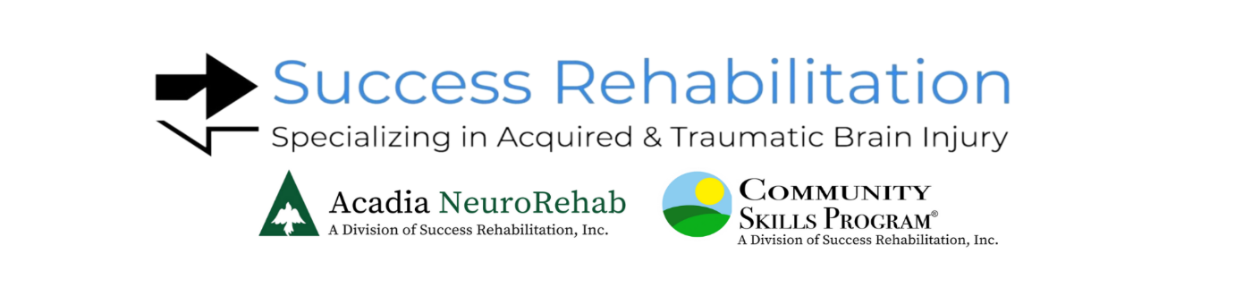

The following is a list of services which are available through the divisions of Success Rehabilitation and community access.

- Activities of Daily Living (ADLS and IADLS)
- Art Therapy
- Behavioral Management
- Brain Injury Education
- Case Management
- Chaplaincy Program
- Cognitive Rehabilitation Therapy (CRT)
- Cognitive Technology Service
- Comprehensive Skills Training
- Community Activities
- Equestrian
- Group Psychotherapy
- Individual Psychotherapy
- Music Therapy (Individual and Group)
- Neurocognitive Program
- Nursing/Medical Management
- Nutritional Counseling
- Occupational Therapy
- Pet Therapy
- Physical Therapy
- Post-Concussion Intensive Program
- Psychiatric Services
- Recreational/Leisure Activities
- Socialization/Peer Interaction
- Speech/Language Pathology
- Success NeuroRehab-Interdisciplinary Outpatient Medical Rehabilitation
- Telehealth
- Veteran Services
- Vocational Counseling Services
- Wellness Services- Yoga, Healthy Cooking/Menu Planning, Cardio Group,
Strengthening/Mobility Management

